**Love Alarm Season 2: Release Date and other details!** 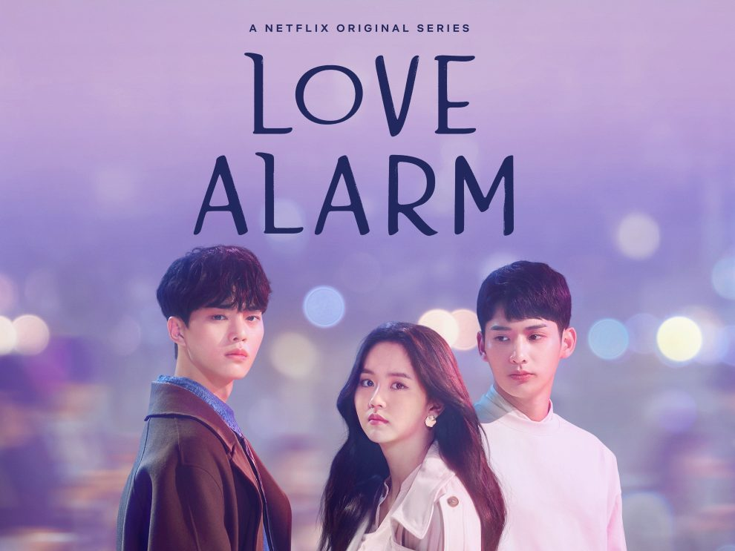

**Love Alarm**, a south Korean teen drama, and **Netflix** original television **series** grounded on the webtoon of the same name by Chon Kye-young. It was developed by Jiyoung Park for Studio Design. Lee Ah-Yeon wrote **season** 1 of Love Alarm while Kim Jin-woo wrote **season 2**. It's starring Kim So-Hyun, Jung Ga-ram, and Song Kang as the lead role.

**Love Alarm Season 2: Release Date**

**Love Alarm Season** 1 streamed on **Netflix** on August 22, 2019. It became a huge success and was ranked as one of the top *Netflix* releases in 2019. Thus, the creator announced the renewal of **Love Alarm** for **season 2** on October 29, 2019. The cast of the series gathered on February 21, 2020, for the script reading of **Love Alarm Season 2**. Thus, it was anticipated that **season 2** will release by August 2020 but because of the ongoing pandemic, the series production was delayed and the premiere of season 2 is pushed to 2021.

**Love Alarm Season 2: Probable Cast**

The lead characters are likely to repeat their roles. Apart from them, new characters may appear but nothing has been unveiled yet. So, let's catch up with the characters who appeared in **season** 1 and are likely to appear in **season 2**:

**Kim So Hyun** being **Kim Jo-jo**- She's the protagonist of the series. Kim Ji-woo played the role of young Kim Jo-jo. She's the pretty girl who is the love interest of another two leading characters, Hwang Sun-oh and Lee Hye-Yeong. She caught herself in a love triangle and so the series plotline depends on whom she chose as her partner. Earlier in her childhood days, she caught herself in many hardships. She's an extraordinary girl, who despite going through so many family hardships acts as a cheerful girl.

**Song Kang** being **Hwang Sun oh**- Kim Ji woo played the role of young Sun-oh. He's an attractive model who has feelings for Jo Jo. He's the heir of a rich family.

**Jung Ga Ram** being **Lee Hye Yeong**- Jung Ji Hoon played the role of young Lee Hye Yeong. He's Sun Oh's best friend who has feelings for Jo Jo.

Z. Hera being Kim Jung -go

Shin Seung-ho being Sik

Go Min-si being Park Gul-mi

Lee Jae-Eung being Cheong Duk Gu- He's the developer of the Love Alarm application on which the whole series is based.

Song Sun-mi being Jeong Mi mi

Shim Yi young being Hye Young's mother

Park Sung Yun being Jo jo's aunt and Gul mi's mother

Kim Young ok being jo-jo's grandmother

Song Geon hee being Marx

Kim Si Eun being Lee Yuk jo

Jo Yoo Jung being Mon Sun 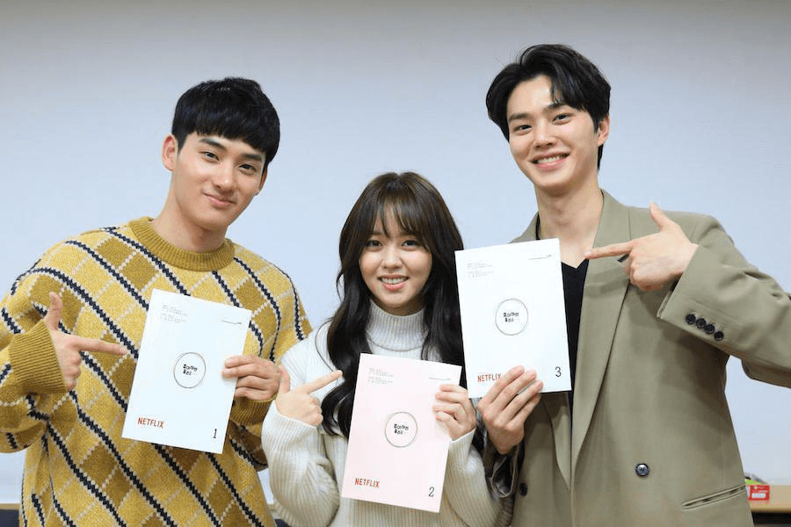

**Love Alarm Season 2: Expected Plot**

It revolves around the storyline of a dating app, the *Love Alarm application* developed by Cheong Duk Gu, which's capable to find out if someone under the vicinity of the 10m radius has romantic feelings for that person who's at the center. Love Alarm application notifies its users if anyone under the vicinity of the 10m radius has feelings for them. Because of this application, *Jo-jo* finds herself caught in a love triangle between *Lee Hye-Yeong* and *Hwang Sun-oh*. So, the **Love Alarm Season 2** is likely to revolve around Jo-jo, who's having the choice to choose between any of the two boys. So, let's wait for **season 2** and see whom does Jo Jo chooses.

**Love Alarm Season 2: Trailer**

There's no separate **trailer** for **season 2** as of now. So, you can enjoy the official **trailer** released on **Netflix** on August 6, 2019😊

<https://www.youtube.com/watch?v=8sXTfzaLmiQ&feature=youtu.be>